WHARTON WOLVES SOCCER CLUB

BOARD MEETING AGENDA

horizontal line **07/15/2025 7:00pm / Virtual**

BOARD MEMBERS: Start- 7:00

* Jennifer Parsells, President- present
* Michelle Molde, Vice President- absent
* Jennifer Joana, Treasurer- present
* Stephanie McCabe, Secretary- absent
* Grace Martinez, Player Agent(Rec)- present
* Mike Molde, Player Agent (Travel)- absent
* Board Minutes
  + Board minutes are on the Wharton Soccer Club Website under the “Club Info” tab.
* Correspondence
  + Emails about summer camp and rec soccer registration
  + Parents were notified about summer camp being canceled- parents would like a refund
  + Mrs. McCoullough was contacted - she would like a credit for the Fall 2025 season and said the communication was poor (both Mrs. McCollough and her son were notified about the Spring 2025 season by email and WhatApp) (jenn p - check to see if credit was applied, if not create coupon code for her to use).
* Treasury Report
  + TD Bank Account Balance: (as of 7/15/2025) $11,495.14
  + Town Account Balance: (Spring 2025) $8300
    - Jenn P submitted the Field lining invoice for reimbursement on 7/15
  + Outstanding Invoices/Receipts:
  + Pending Transactions:
    - Summer Camp Refunds - sent 7/14 $583.40
    - Spring RVSL Fees- sent 7/14 $250
    - Spring Ref Assignor Fees - sent 7/14 $298.50
    - Travel Tournament Refund $390 (pending payment) ($30 per child).
    - Coach Rebates - need more guidance prior to issuing (double check the powerpoint to see if the coupon code/coach discount is described).
* Committee Report
  + Uniforms: None
  + Fundraising: Michelle Obiedzinski- need to follow up about Miner’s Apron.
  + Concessions:
  + Maintenance:
* Travel Reports
  + Travel Registration Numbers:As of 7/15 meeting
  + 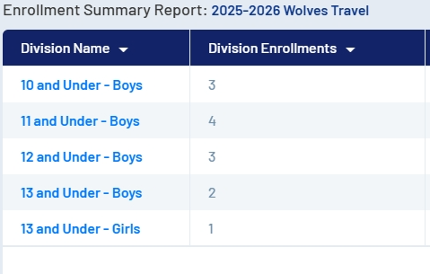
* Delegates
  + MCYSA : Registration is open. Must have teams registered by 7/31 at midnight. Jenn & Grace will discuss numbers again on July 29th to determine if a team will be registered for the U11’s (combining U10 & U11 together).
  + RVSL: Greensheets due by Aug 17th. Season dates: Sept 13th thru Nov 8th.
* Unfinished Business
  + Turf field application for the Fall is still tabled from the Wharton BOE- they will be discussing the policy soon.

* New Business
  + Travel Registration is open (see report above)
  + Bench with shade for game fields on upper field- the club is in agreement that we need to upgrade the benches. Find a company and get a quote for updated benches - or find a solution for an [adaptation](https://www.scheels.com/p/61730501882/?store=&msclkid=716b56cb2ef116f8c6543ebdca783277&utm_source=bing&utm_medium=cpc&utm_campaign=Bing%20Shopping&utm_term=4585100934695489&utm_content=Bing%20Shopping_29%20-%20Team%20Sports) of what is already there. [Nissel](https://gowinningteams.com/european-team-shelter.aspx) has shelters
  + Scrimmage Policy- needs to be put into writing - discuss @ Aug meeting and vote at Sept meeting to add the addendum to the by-laws.
  + Sponsorship Letters to Local Businesses - Jenn & Michele Molde need to review and get back to Grace with any changes. Need to find a vendor for printing banners for the upper field.
  + Graduating senior scholarship opportunity - the club will look into this. Is that a TD Bank question? Ask Cruz family if they still wanted to contribute.

Meeting adjourned at: 7:27 pm

Next Meeting is August 19, 2025 at Robert Street Park at 7 pm.